Grading Guidelines:

A right answer will get full credit when:

1. It is right (worth 25%)
2. It is right **AND** neatly presented making it easy and pleasant to read. (worth an **extra** 15%)
3. There is an **obvious and clear link** between 1) the information provided in the exercise and in class and 2) the final answer. A clear link is built by properly writing, justifying, and documenting an answer (worth an **extra** 60%).
4. Calculation mistakes will be minimally penalized (2 to 5% of full credit) while errors on units will be more heavily penalized.

**Late Submission** : as specified in the syllabus. Days counting starts one minute after the deadline.

You are welcome/encouraged to discuss exercises with other students or the instructor. But, ultimately, **personal** writing is expected.

* USE THIS FILE AS THE STARTING DOCUMENT YOU WILL TURN IN. **KEEP IN THE QUESTIONS** AND INSERT YOUR ANSWERS.
* IF USING HAND WRITING (STRONGLY DISCOURAGED), REWRITE THE QUESTIONS.
* FAILING TO FOLLOW TURN IN DIRECTIONS /GUIDELINES WILL COST A 30% PENALTY.

Objectives of this assignment:

* to learn consider some issues about port numbers
* to explore issues related to the maximum size of TCP segments.

What you need to do:

Complete the tasks below:

KEEP THE GRADING GUIDELINES ABOVE TO REMEMBER THE DIRECTIONS AND HOW THE HOMEWORK IS GRADED.

Objective: The objective of this assignment is to explore command line Unix (Linux) tools to open and use UDP and TCP connections. This assignment will explore the tip of the tip of the iceberg (the nc (netcat) command, known also as netcat command). You can read about it on the INternet.

Resources:

1. **Textbook:** Tanenbaum, Andrew S. and David J. Wetherall. *Computer Networks*.
2. Module 6 lectures
3. Your instructor
4. Wikipedia
5. Internet

Note that the textbook, Module 6 material, and your instructor are sufficient to answer all questions in this homework as well as the related self-study questions.

**UDP Connections (50 points)**

1) Open three terminals T1, T2, and T3 on your local machine. Insure the font is large enough to produce **readable** screenshots. Screenshots hard to read will be considered missing. Remotely connect terminals T1 and T2 to the same Tux Machine A. Remotely connect the third terminal T3 to a different Tux Machine B. (Refer to the video posted with this assignment if you do not understand or if you need help. Do not hesitate to ask help on Piazza or reach out to the teaching assistant)

2) After Terminal T1 is connected to Tux Machine A, you must set up a UDP server on it bound to Port # (10010 + TeamNumber) where TeamNumber is your Canvas team number for this assignment. For example, if your Canvas group for this assignment is Team 57, the server must bind to your assigned Port # 10067 (=10010+57). Here is the command to set up a UDP server bound to Port # 10067 (**recall to use your assigned port # based on your own team #, not the port #10067**) from Terminal T1:

**nc -u -l 10067**

3) (16 points) Follow these steps:

a) enter the command **date** on Terminal T1

b) Set up through Terminal T1 a UDP server at your assigned port # (10010 + TeamNumber) using the command nc command.with the appropriate port #. For this, just enter the right nc command with the appropriate parameters.

c) Provide a screenshot that shows the date, username, the tux machine, the executed nc command, and its result. Crop the screenshot to save space and show only the needed information.

This is my screenshot from my first terminal. I used the tux machine 060 here. You can see the UDP server being launched and the two resulting messages I sent.

4) (24 points) The objective is to set up a UDP client on Terminal T3. Suppose that you set the server on Tux machine tux0**64** on port # 10067. The IP address of the Tux machine tux064 is 131.204.14.64. In this case, you can set a client on Terminal T3 by entering the command

**nc -u 131.204.14.64 10067.**

Note that you can use the tux machine name tux064.eng.auburn.edu (or just tux064 because client and server are in the same domain eng.auburn.edu) instead of its IP address. Follow these steps to set up the UDP client and send sentences to the UDP server:

a) enter the command **date** on Terminal T3

b) enter the nc command to set up a client on Terminal T3 that will communicate with the UDP server you previously set up above on Terminal Terminal T1. For this, just enter the right nc command with the appropriate parameters.

c) Type the sentence " Hello World" on Terminal T3. The same sentence should appear on the terminal T1 where the UDP server is set.

d) Type the sentence " Hello from Team nn" on Terminal T3 where *nn* is your team #. The same sentence should appear on the terminal T1 where the UDP server is set.

e) Provide a screenshot on the Terminal **T1** that shows the date, username, the tux machine, the executed nc command, and the received sentences. Crop the screenshot to save space and show only the needed information.

f) Provide a screenshot on the Terminal **T3** that shows the date, username, the tux machine, and the executed nc command, and the received sentences. Crop the screenshot to save space and show only the needed information.

5) (10 points) The objective of this task is to check whether there is a UDP server active on your assigned port # (10010 + TeamNumber). Here are the actions to perform to achieve this objective:

a) enter the command **date** on Terminal T2.

b) enter the command **netstat | grep udp** on Terminal T2. netstat displays network connections..... If you use only netstat, you would get too many lines. Using the command grep will select only lines that include the string "udp".

c) Provide a screenshot that shows the date, username, the tux machine, the executed netstat command, and its result. Crop the screenshot to save space and show only the needed information.

After executing the command you can see that there is in fact an established connection using the port 10018.

**TCP Connections (50 points)**

1) Open three terminals T1, T2, and T3 on your local machine. Insure the font is large enough to produce readable screenshots. Remotely connect terminals T1 and T2 to the same Tux Machine A. Remotely connect the third terminal T3 to a different Tux Machine B. (Refer to the video posted with this assignment if you do not understand or if you need help. Do not hesitate to ask help on Piazza or reach out to the teaching assistant)

2) After Terminal T1 is connected to Tux Machine A, you must set up a TCP server on it bound to Port # (10010 + TeamNumber) where TeamNumber is your Canvas team number for this assignment. For example, if your Canvas group for this assignment is Team 57, the server must bind to your assigned Port # 10067 (=10010+57). Here is the command to set up a TCP server bound to Port # 10067 (**recall to use your assigned port # based on your own team #, not the port #10067**) from Terminal T1:

**nc -l 10067**

3) (16 points) Follow these steps:

a) enter the command **date** on Terminal T1

b) Set up through Terminal T1 a TCP server at your assigned port # (10010 + TeamNumber) using the command nc command.with the appropriate port #. For this, just enter the right nc command with the appropriate parameters.

c) Provide a screenshot that shows the date, username, the tux machine, the executed nc command, and its result. Crop the screenshot to save space and show only the needed information.

To this point I have started the TCP server. There is no return message at this time.

4) (10 points) The objective of this task is to check whether there is a TCP server active on your assigned port # (10010 + TeamNumber). Here are the actions to perform to achieve this objective:

a) enter the command **date** on Terminal T2.

b) enter the command **netstat | grep tcp** on Terminal T2. netstat displays network connections..... If you use only netstat, you would get too many lines. Using the command grep will select only lines that include the string "tcp".

c) Provide a screenshot that shows the date, username, the tux machine, the executed netstat command, and its result. Crop the screenshot to save space and show only the needed information.

5) (24 points) The objective is to set up a TCP client on Terminal T3. Suppose that you set the server on Tux machine tux0**64** on port # 10067. The IP address of the Tux machine tux064 is 131.204.14.64. In this case, you can set a client on Terminal T3 by entering the command

**nc 131.204.14.64 10067.**

Note that you can use the tux machine name tux064.eng.auburn.edu (or just tux064 because client and server are in the same domain eng.auburn.edu) instead of its IP address. Follow these steps to set up the TCP client and send sentences to the TCP server:

a) enter the command **date** on Terminal T3

b) enter the nc command to set up a client on Terminal T3 that will communicate with the TCP server you previously set up above on Terminal Terminal T1. For this, just enter the right nc command with the appropriate parameters.

c) Type the sentence " Hello World" on Terminal T3. The same sentence should appear on the terminal T1 where the TCP server is set.

d) Type the sentence " Hello from Team nn" on Terminal T3 where *nn* is your team #. The same sentence should appear on the terminal T1 where the TCP server is set.

e) Provide a screenshot on the Terminal **T1** that shows the date, username, the tux machine, the executed nc command, and the received sentences. Crop the screenshot to save space and show only the needed information.

f) Provide a screenshot on the Terminal **T3** that shows the date, username, the tux machine, and the executed nc command, and the received sentences. Crop the screenshot to save space and show only the needed information.

**What you need to turn in**:

* Electronic copy of this file (including your answers) (standalone). Submit the file as a Microsoft Word or PDF file.
* Recall that answers (if applicable) must be well written, documented, justified, and presented to get full credit.
* How this assignment will be graded: grades will be based on the screenshots only.
* You are welcome/encouraged to discuss exercises with other students or the instructor. But, ultimately, personal work is expected.

**Appendix**: Grading: What is an OBVIOUS and CLEAR LINK?

Here is an example to explain what an **obvious and clear link** is and how we grade your work.

Consider the following problem:

"(100 points) John travels from Auburn to Atlanta in his car at a speed of 60 mph. Leaving at 8am, at what time will John reach Atlanta".

Here are the answers of three students and their scores:

* **Student 1** answers: "9:48am". Student 1 will get 25 points.
* **Student 2**answers : "John will reach Atlanta at 9:48am". Student 2 will get 25+15 = 40 points
* **Student 3** answers: "The time t to travel a distance d at speed v is equal to d/v = d/60mph. The problem does not provide the distance d from Auburn to Atlanta. Based on GoogleMaps, the distance from Auburn to Atlanta is approximately 108 miles (**document is attached**).

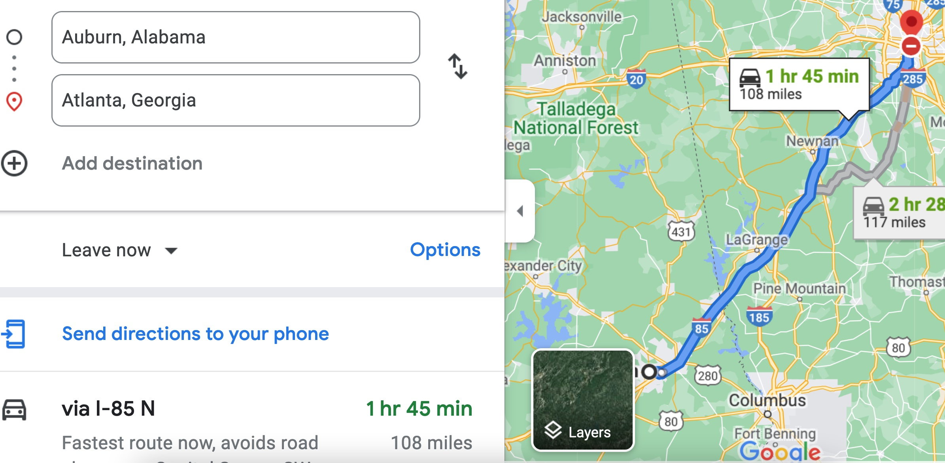

Therefore, the time t = 108 miles/60mph * 60 minutes/hour= 108 minutes. Since John left at 8am, he will then reach Atlanta at 8am + 108 minutes = 8 am + 60 minutes + 48 minutes = 9:48".

**Student 3** will get 25 + 15 + 60 = 100 points

Do you see the **direct** **link** going from the data provided in the question to the final answer, using general knowledge/formula and documents?.... Can you now solve the following problem and get 100 points?

"(100 points) Alice travels from Auburn to Atlanta in her car at a speed of 60 mph. Leaving at 8am, at what time will Alice reach Atlanta assuming that she had a flat tire that delayed her 30 minutes".